Cloud-based DBMS

☁️ What Is a Cloud-Based DBMS?
# Source: AI Source: Provided by: [Data Path: Persons Table -> ID Column: 1, Name_En Column: Motasem Essam] -> From: [ChatGPT] on [6/10/2026]
A Cloud-Based DBMS is a database management system that runs on cloud infrastructure, rather than being installed and managed on your own local server or data center.
It provides all the features of a traditional DBMS, but hosted and managed in the cloud, often by providers like Amazon, Microsoft, or Google.

🔍 Key Characteristics
# Source: AI Source: Provided by: [Data Path: Persons Table -> ID Column: 1, Name_En Column: Motasem Essam] -> From: [ChatGPT] on [6/10/2026]
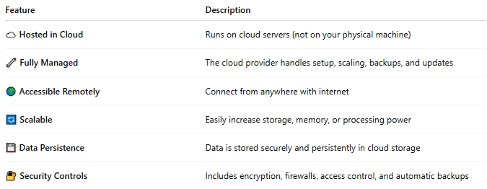
Feature | Description
☁️ Hosted in Cloud | Runs on cloud servers (not on your physical machine)
🔧 Fully Managed | The cloud provider handles setup, scaling, backups, and updates
🌍 Accessible Remotely | Connect from anywhere with internet
🔄 Scalable | Easily increase storage, memory, or processing power
💾 Data Persistence | Data is stored securely and persistently in cloud storage
🔐 Security Controls | Includes encryption, firewalls, access control, and automatic backups

🧰 Examples of Cloud-Based DBMSs
# Source: AI Source: Provided by: [Data Path: Persons Table -> ID Column: 1, Name_En Column: Motasem Essam] -> From: [ChatGPT] on [6/10/2026]
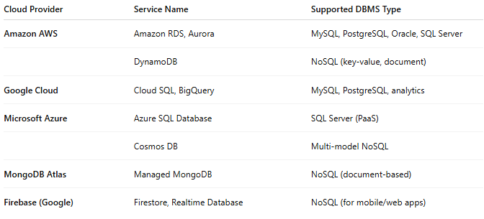
Cloud Provider | Service Name | Supported DBMS Type
Amazon AWS | Amazon RDS, Aurora | MySQL, PostgreSQL, Oracle, SQL Server
 | DynamoDB | NoSQL (key-value, document)
Google Cloud | Cloud SQL, BigQuery | MySQL, PostgreSQL, analytics
Microsoft Azure | Azure SQL Database | SQL Server (PaaS)
 | Cosmos DB | Multi-model NoSQL
MongoDB Atlas | Managed MongoDB | NoSQL (document-based)
Firebase (Google) | Firestore, Realtime Database | NoSQL (for mobile/web apps)

🧪 Use Case Scenarios
# Source: AI Source: Provided by: [Data Path: Persons Table -> ID Column: 1, Name_En Column: Motasem Essam] -> From: [ChatGPT] on [6/10/2026]
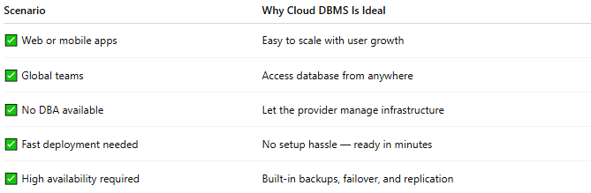
Scenario | Why Cloud DBMS Is Ideal
✅ Web or mobile apps | Easy to scale with user growth
✅ Global teams | Access database from anywhere
✅ No DBA available | Let the provider manage infrastructure
✅ Fast deployment needed | No setup hassle — ready in minutes
✅ High availability required | Built-in backups, failover, and replication

⚖️ Pros and Cons
# Source: AI Source: Provided by: [Data Path: Persons Table -> ID Column: 1, Name_En Column: Motasem Essam] -> From: [ChatGPT] on [6/10/2026]
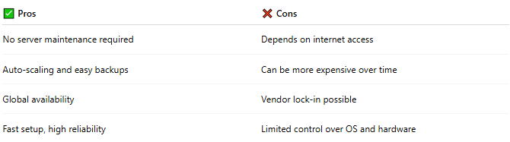
✅ Pros | ❌ Cons
No server maintenance required | Depends on internet access
Auto-scaling and easy backups | Can be more expensive over time
Global availability | Vendor lock-in possible
Fast setup, high reliability | Limited control over OS and hardware

🧭 On-Premise vs Cloud-Based DBMS
# Source: AI Source: Provided by: [Data Path: Persons Table -> ID Column: 1, Name_En Column: Motasem Essam] -> From: [ChatGPT] on [6/10/2026]
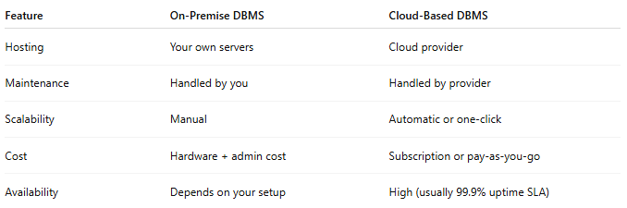
Feature | On-Premise DBMS | Cloud-Based DBMS
Hosting | Your own servers | Cloud provider
Maintenance | Handled by you | Handled by provider
Scalability | Manual | Automatic or one-click
Cost | Hardware + admin cost | Subscription or pay-as-you-go
Availability | Depends on your setup | High (usually 99.9% uptime SLA)

📌 Summary
# Source: AI Source: Provided by: [Data Path: Persons Table -> ID Column: 1, Name_En Column: Motasem Essam] -> From: [ChatGPT] on [6/10/2026]
A Cloud-Based DBMS is a modern solution that runs your database in the cloud, allowing you to focus on your app, not the infrastructure. It's perfect for scalability, remote access, and ease of use.

